Promotion Announcement Email

**Email Subject Line:** [**Full name of employee’s] promotion to [New role]**

Dear [Team name],

I’m excited to share some great news: [Employee's full name] has been promoted to [New role] in the [Department name].

Since joining [Company/Project name] as [Previous role], [Employee's first name] has shown exceptional dedication and skill, particularly in identifying opportunities to help our customers solve additional challenges.

[Employee's first name] has worked closely with team members to strategize opportunities and has also been mentoring new team members.

In their new role, [Employee's first name] will be involved in shaping strategy and supporting the team in reaching [relevant goals / targets].

[Employee's first name] has been instrumental in helping us achieve key milestones over the past [time period], and we’re thrilled to see them step into this new role. This promotion is well-deserved and reflects their hard work and the positive impact they bring to the team every day.

Please join me in congratulating [Employee's first name] on this exciting new chapter.

Best regards,  
[Your full name]  
[Your job title]

[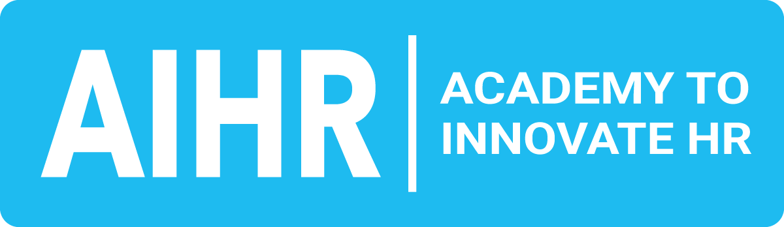](http://aihr.com)

[aihr.com](https://www.aihr.com/)

Internal Promotion Announcement

Dear team,

We are excited to share that [Employee's full name] has been promoted to the position of [New role] in the [Department name]. This well-earned promotion is a reflection of their dedication, hard work, and the positive impact they have consistently made on our team.

Over the past [time period], [Employee's first name] has demonstrated exceptional skills and a commitment to excellence that has been an asset to our organization.

In their new position, [Employee's first name] will take on [key responsibilities*]*. We are confident that their expertise, combined with their passion for [relevant pursuits or goals], will continue to contribute significantly to the success of our team.

Please join us in celebrating this milestone and congratulating [Employee's first name] on this achievement. We encourage everyone to offer their support as they embrace this new chapter and further their contributions to [organizational goals or vision].

Best regards,  
[Your full name]  
[Your job title]

[](http://aihr.com)

[aihr.com](https://www.aihr.com/)

LinkedIn Promotion Announcement

📢 📢 **We’re thrilled to announce [full name of employee's] promotion to [New role] at [Company name].** 📢 📢

As [Previous role],[Employee's first name] has been an invaluable member of our team for [time period], consistently demonstrating exceptional skills in helping our customers identify and unlock greater value through our products and solutions.

In their new position as [New role], they will take on leadership, mentoring, and more strategic responsibilities, driving even greater impact within the [Department name].

[Employee's first name] journey is a testament to our commitment to supporting talent and fostering growth from within. We are incredibly proud of their accomplishments and excited to see how they will continue to contribute to our success. 💫 💫

Please join us in congratulating [Employee's first name] on this well-deserved promotion. 👏👏

#PromotionAnnouncement #NewRole #CareerGrowth #EmployeeRecognition #*[Company name]*

](http://aihr.com)

[aihr.com](https://www.aihr.com/)

[](https://www.aihr.com/platform/?utm_source=resource&utm_medium=resource&utm_campaign=templates&utm_content=templates)